**SES:**

An emerging concept and framework for understanding the intertwined nature of human and ecological systems​

Developed in the **early to mid-1990s** through the collaboration of scholars working in the interdisciplinary areas of ecological economics and common-pool resource systems (**Berkes 1989, Ostrom 1990, Costanza 1991**)​

**SES is cohesive, integrated systems characterized by strong connections and feedbacks within and ,between social and ecological components that determine their overall dynamics (Folke et al. 2010, Biggs et al. 2015)​**

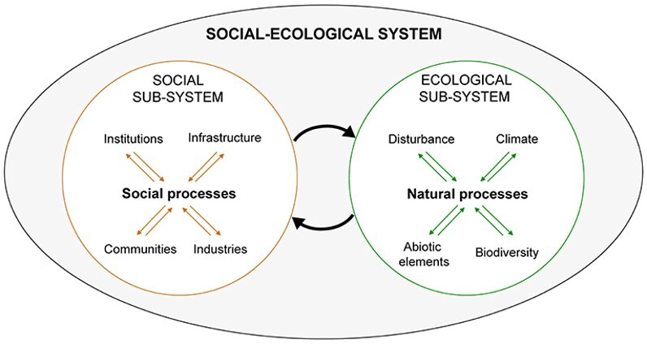

* **“social” : (patterned) interrelationships and interactions among individuals, groups, surrounding biophysical (nonhuman) entities and institutions (knowledge, practice, beliefs, norms) [Herbert Spencer, Émile Durkheim]. ​**
* **“ecological”: dynamic interrelationships and interdependencies among biotic (all living beings including human) and abiotic (material) components of nature [A.G Tansley, E.P. Odum]​**

**​**

* **“system”: a set of elements – “people, cells, molecules, or whatever – interconnected in such a way that they produce their pattern of behaviour over time’ through the repeated cycles of input, throughput, output, and feedback [Ludwig von Bertalanffy]**

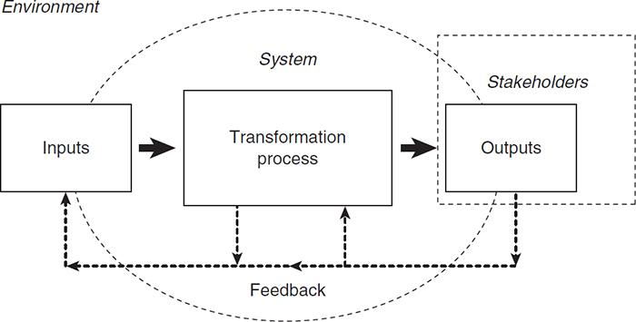

“SES is understood as an intertwined CAS, embedded in Biosphere”(COMPLEX ADAPTIVE SYSTEMS)

* **Relations and interactions**
* **Feedback and adaptive capacity –** feedback processes enable to continuously adjust and adapt
* **Non-linearity** – interactions are dynamic and may change in unusual way; small changes can trigger larger implications; e.g. ice sheet collapse, a shift from collaborative institutions for regulating fishing to overharvesting
* **Unpredictability** - complex cause and effect pathways; co-evolutionary nature

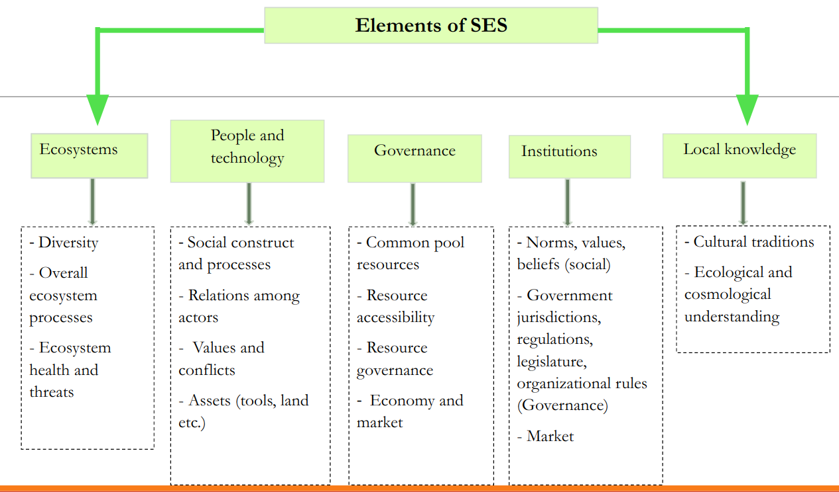

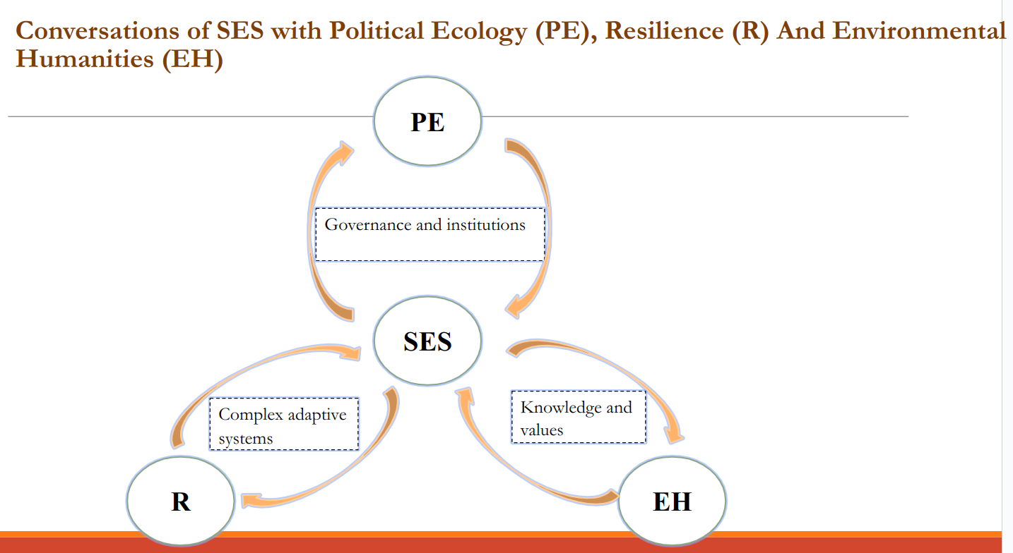

To explain social-ecological systems with an example, let's consider a coastal community that relies on fishing as its main source of livelihood. The social system in this case includes the people, their culture, and their institutions, while the ecological system includes the fish populations, the marine ecosystems, and the climate.

Changes in the ecological system can have a significant impact on the social system. For example, if overfishing or changes in the ocean's temperature or acidity reduce the fish populations, it can lead to a decline in the community's economic well-being and food security. This can in turn lead to social and cultural changes, such as migration, changes in dietary habits, and a loss of cultural practices related to fishing.

On the other hand, changes in the social system can also have an impact on the ecological system. For instance, if the community adopts unsustainable fishing practices or ignores regulations, it can lead to the overexploitation of fish populations and the degradation of marine ecosystems. This can have long-term consequences not only for the fish populations but also for the livelihoods and well-being of the community.

Therefore, understanding the social-ecological system in this case involves analyzing the interactions between the social and ecological systems, and identifying strategies that promote sustainable fishing practices while ensuring the long-term viability of the fish populations and the ecological systems on which they depend. This requires collaboration between different stakeholders, including the fishing community, government agencies, and environmental organizations, among others, to ensure the sustainable management of the coastal ecosystem.

**CAS & SES:**

**Ludwig, Gregory, Foerster**

Complex adaptive systems and social-ecological systems are closely related concepts. In fact, social-ecological systems are a specific type of complex adaptive system.

**A complex adaptive system (CAS) is a system composed of many interacting components that can adapt and evolve in response to changes in their environment**. CASs are characterized by non-linear feedback loops, emergence, self-organization, and adaptation.

Social-ecological systems (SES) are complex adaptive systems that integrate social and ecological components. SESs are composed of people and the natural environment they interact with. These systems are characterized by the interdependence of social and ecological systems, feedback loops, and adaptive cycles. In an SES, changes in the environment can lead to changes in the social system, and vice versa.

Both complex adaptive systems and social-ecological systems are dynamic and complex, with multiple feedback loops and nonlinear relationships between components. They also both exhibit emergent properties, meaning that the system as a whole displays behaviors that cannot be predicted solely from the behaviors of individual components.

Understanding the relationship between complex adaptive systems and social-ecological systems is important for understanding the dynamics of human-environment interactions and for designing policies and management strategies that promote sustainability and resilience in these systems.

Both complex adaptive systems and social-ecological systems are subject to disturbances and shocks that can have cascading effects throughout the system. For example, a sudden change in climate can lead to changes in ecosystems, which in turn can affect the livelihoods and well-being of people who depend on those ecosystems. Similarly, changes in social systems, such as economic or political shifts, can have effects on the natural environment.

Managing complex adaptive systems and social-ecological systems requires an understanding of their inherent complexity, the interconnectedness of their components, and the potential for unexpected outcomes. Traditional management approaches that focus on controlling or manipulating individual components may not be effective in these systems, and may even lead to unintended consequences.

Instead, approaches that promote resilience, adaptation, and learning are needed. This requires engaging stakeholders in collaborative decision-making, fostering social learning and innovation, and building adaptive capacity at multiple levels. It also requires acknowledging and addressing power imbalances, promoting equity and social justice, and integrating diverse knowledge systems and perspectives.

In summary, social-ecological systems are a specific type of complex adaptive system that integrate social and ecological components. Understanding and managing these systems requires an approach that is adaptive, collaborative, and takes into account the complexity and interconnectedness of their components.

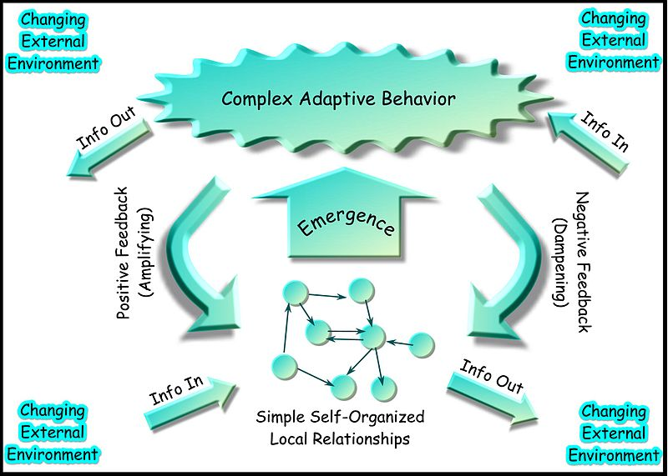

1. Exploration of Complex Relationships
2. Identification of Underlying Causes
3. Recognition of Multiple Influencing Factors
4. Interdisciplinary Approach
5. Contributions to Understanding
6. Framework for Evidence-Based Solutions
7. Comprehensive Understanding
8. Effective Solutions to Problems.